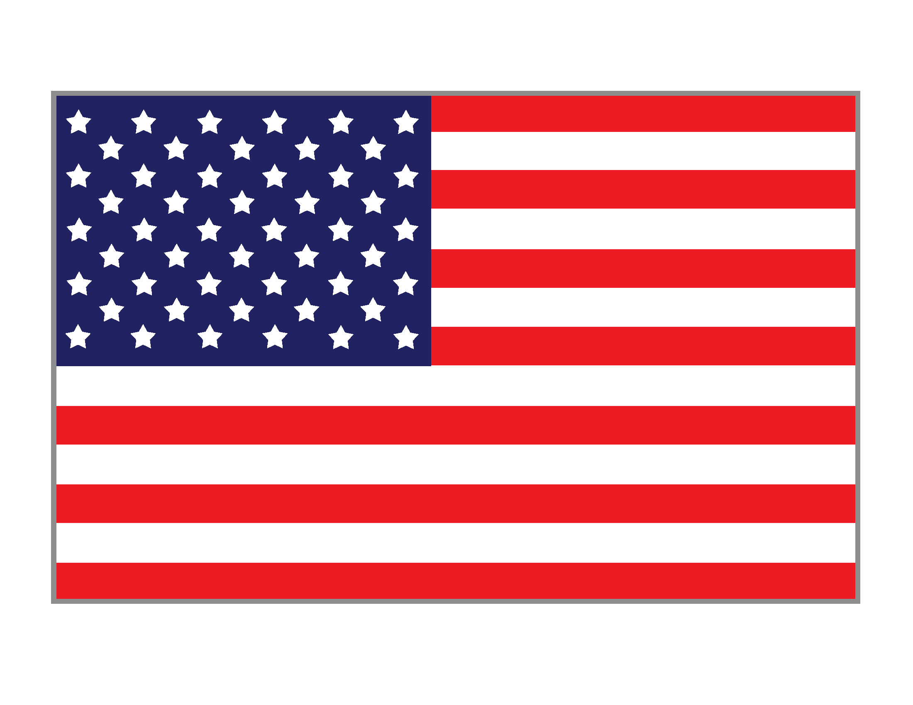

**Roberto Clemente State Park Presents FREE**

**Winter Indoor Instructional Baseball Program**

**Space is LIMITED / First Come - First Served & Proof of age is **REQUIRED**\*\*

**Ages 5 to 7 Years Old**

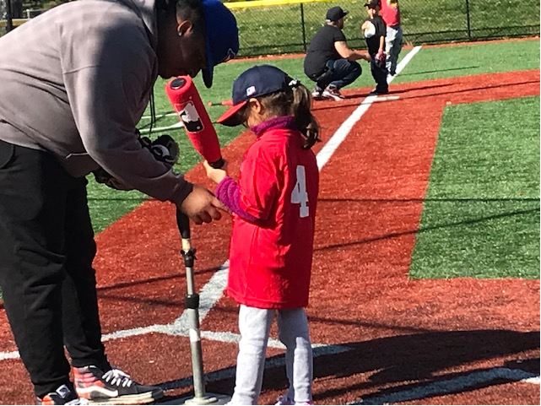

**Ages 5 to 7 Years Old** **Ages 5 to 7 Years Old**

**9:00 AM to 10:15 AM 10:30 AM to 11:45 AM**

Saturday, January 21st Saturday, March 4th

Saturday, January 28th Saturday, March 11th

Saturday, February 4th Saturday, March 18th

Saturday, February 11th Saturday, March 25th

Saturday, February 18th Saturday, April 1st

Register here at: <http://rcsprbi.leagueapps.com/events/3634398-winter-indoor-instructional-baseball-program-2023>

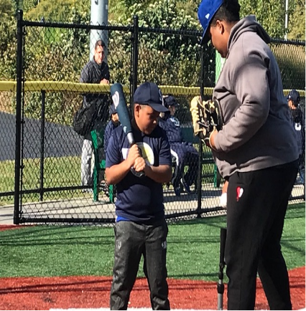

**Ages 8 to 10 Years Old**

**Ages 8 to 10 Years Old** **Ages 8 to 10 Years Old**

**9:00 AM to 10:15 AM 10:30 AM to 11:45 AM**

Saturday, March 4th Saturday, January 21st

Saturday, March 11th Saturday, January 28th

Saturday, March 18th Saturday, February 4th

Saturday, March 25th Saturday, February 11th

Saturday, April 1st Saturday, February 18th

For more info contact John Doherty @ 718-299-7264 or john.doherty@parks.ny.gov

